YOU ARE INVITED TO

A

CELEBRATION OF A WONDERFUL LIFE

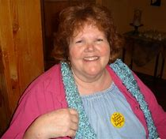

MELINDA WALLIS (October 16, 1941 - Feb. 18, 2018)
SATURDAY, MARCH 10^{TH,} 2018 AT 3 PM
SUBUD GREATER SEATTLE CENTER,
1101 15TH AVE., SEATTLE, WA 98022

- INFORMAL SERVICE and SHARING

- CREATE A MURAL TO BE DISPLAYED AT THE SUBUD USA NATIONAL CONGRESS

BRING A DESSERT TO SHARE

